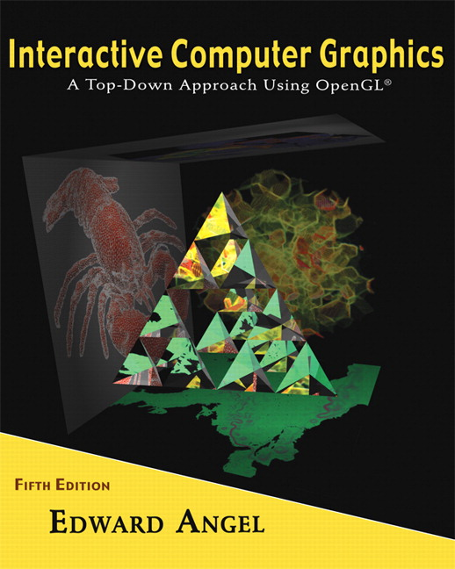

Name: ______________________ Terminal # ____

Programming Assignment 4
(100 points)

The Programming Assignment is to be turned in the first ten minutes of the due date class as:

Hardcopy (with your terminal #!)
Source Code and screenshots that shows that your Visual Studio 2010 “Programming Assignment 4” PROJECT compiles and runs!
Electronic: Submit the Visual Studio2010 “Programming Assignment 4” zipped PROJECT to BB so you can run it in 200 PGH!

Origami JURASIC PARK - Summer 2013 Modeling Instructions

1. The glutCreateWindow OpenGL call will take as parameter “YourLastName Final JURASIC PARK”.
2. Start with the LastName JURASIC PARK that you have created in Programming Assignment 3 and call the file LastNameFinalJURASICPARK.c.

3. Particle Systems:
1. Replace sphere and cubes with particle systems sphere and cube, texture map them (happy faces??).

4. Particle Systems:
2. Add the fountain.cpp particle system fountain in the middle of your pond.

5. Navigating:
1. Have duck swim around the fountain in the pond.

5. Navigating:
2. Have dinosaurs walk towards your sphere and cubes with the intent to collide with them. When you collide you can simulate any desired effects like explosion, etc. Successful collision with the 2 objects will mark the completion of your summer project.

5. Navigating:
3. If you have dinosaurs collide with the electric fence surrounding the JURASIC PARK and create a spark and a roar you will get extra credit. (20 points)

Get screenshots of your “YourLastName Final JURASIC PARK” for each view and please comment on what the screenshot is about.

